VERSION HISTORY

VER. | VERSION DETAIL/S | AUTHORED BY: | APPROVED BY: | DATE APPROVED
1.0 | Agreed and SIGNED OFF Guidelines | Indra | Globe ISG | 12/20/2019

DOCUMENT UPDATE HANDLING

The RPA CoE Core team will have a quarterly cadence in order to evolve the documents and to improve the guidelines based on the experiences from previous quarter. The document will have the same people assigned to review and sign-off. In case there are changes in the approvers, the new person assigned to review and update the document must be listed in the version control table of the document

Table of Contents
1. Introduction 3
1.1. Definition 3
1.2. Objective 3
1.3. Scope 3
2. Methodology 3
3. Benefits 3
3.1. Financial Benefits 3
3.2. Non-financial Benefits 3
4. Reporting 4
4.1. PDD Reporting 4
4.2. Orchestrator Dashboard 4
4.3. Elasticsearch and Kibana 5
4.3.1. Elasticsearch 5
4.3.2. Kibana 5

- Introduction
  - Definition
Benefits realization is the process of defining, executing and measuring benefits in a project.

  - Objective
This document aims to define the methodology and guidelines for benefits realization. This will include the usual KPIs to be measured when doing RPA as well as tools to monitor the progress effectively.

  - Scope
The scope of this document includes:
- Methodology
- Benefits
- Reporting

- Methodology
Please refer to the Benefits Realization Management presentation of Product Management Quality & Delivery Operations. This should be the standard for all Globe projects.

- Benefits
Benefits measured should always measureable and have a before and after comparison. There are two types of benefits that are usually present in RPA.
  - Financial Benefits
These are the financial benefits that are usually being measured for RPA initiatives:
- Cost reduction – manhours saved due to RPA
- Risk avoidance – less cost of good will due to mistakes
- Capacity increase – increase in income generating capacity
  - Non-financial Benefits
These are the non-financial benefits that are usually being measured for RPA initiatives:
- Quality of work (% error)
- Customer satisfaction
- Average handle duration
- Capacity increase

- Reporting
  - PDD Reporting
The PDD reporting will differ per business unit per process. Please refer to the PDD document.
  - Orchestrator Dashboard
The UiPath Orchestrator holds the centralized logging, reporting and auditing of all the robots in deployed in production. It can be remotely accessed for managing of robots.
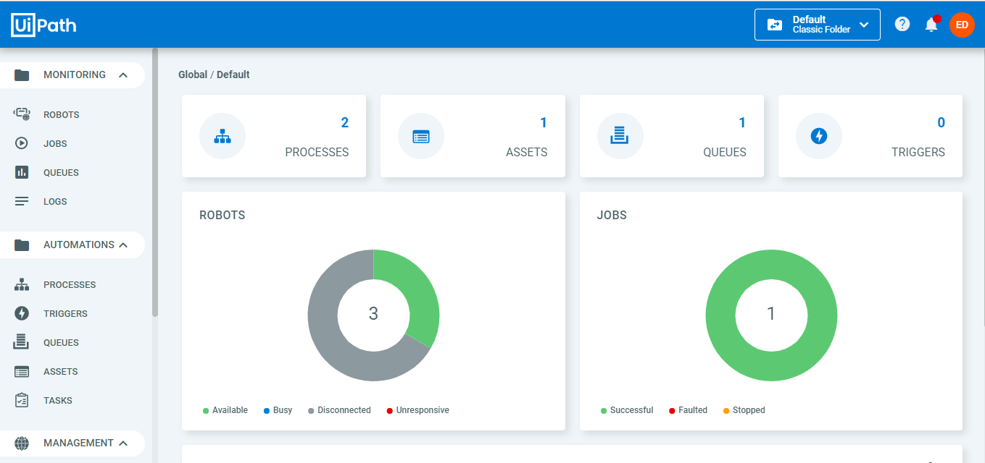
Number of robots can be seen in the main Orchestrator Dashboard. This can be used as a reporting tool for all active robots working on a process.
Queues section of the Orchestrator Dashboard helps you see the transaction overview.
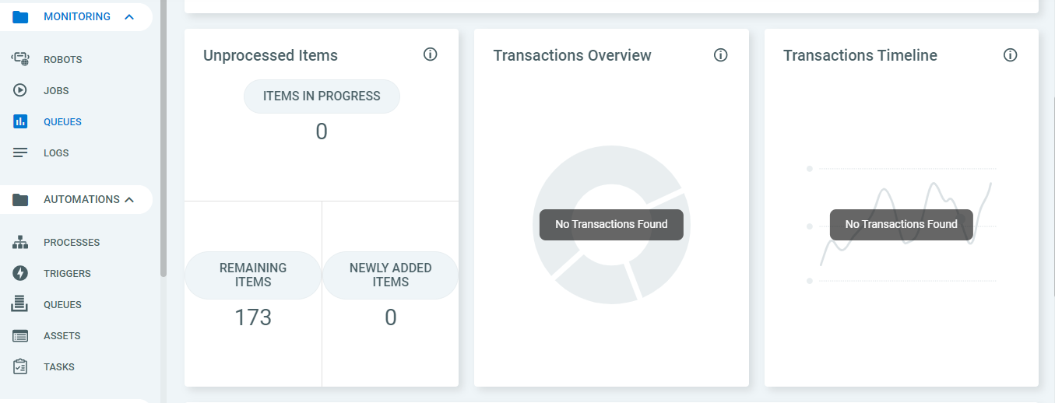
Unprocessed Items lets you know of all unprocessed transactions or fallouts in the processes that the robots encountered.
Transaction Overview on the other hand gives you a rough estimation of all the transactions processed successfully, failed or unprocessed.
Transaction timeline gives you the time when the robots execute the processes assigned to them.
  - Elasticsearch and Kibana
    - Elasticsearch
Elasticsearch is a big data storing tool, a NoSQL database. In general, it stores and index documents. In UiPath Orchestrator, it stores the messages logged by the robots.
USES OF ELASTICSEARCH
  - Search for Word or a phrase in the message;
  - Apply search criteria to any field that is indexed – log level, username, robot name, process name, etc.
  - Create charts and put them in dashboards (using Kibana)
Elasticsearch is one of the integral part of the RPA solution. It is a free product, optional, but highly recommended. It is several times quicker in searches, compared to SQL database. Along with Kibana, it offers a means to run or create reports and analytics.
    - Kibana
Kibana on the other hand is a visualization plugin over Elasticsearch. The UiPath Orchestrator only writes data to Elasticsearch. To query and visualize the stored data, we use Kibana.

